1. ACCESS SPECIFIER
2. SAMPLE PROGRAM
3. GARBAGE COLLECTIONS
4. DATA TYPES & TYPES
5. DATA TYPES CHART
6. OOPS INTRODUCTION

ACCESS SPECIFIER

1. PUBLIC: Global level access [ Inside & outside package ]
2. PRIVATE: Class Level Access [ Inside the class ]
3. PROTECTED: Same like public but we use “extends” keyword
4. DEFAULT: Package Level Access

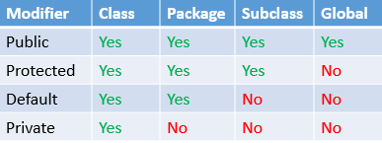

GARBAGE COLLECTION:

1. Unreferenced objects are deleted automatically
2. Unwanted/ unused memory are deleted automatically
3. It is possible only in JAVA not in C, C++ etc

DATATYPES:

Data types specify the different sizes and values that can be stored in the variable.

Need to Declare it

1Byte🡪 8 bit

Primitive data types:

A primitive data type specifies the size and type of variable values, and it has no additional methods.

Non Primitive data types

Non-primitive created by the programmer and is notdefinedby Java

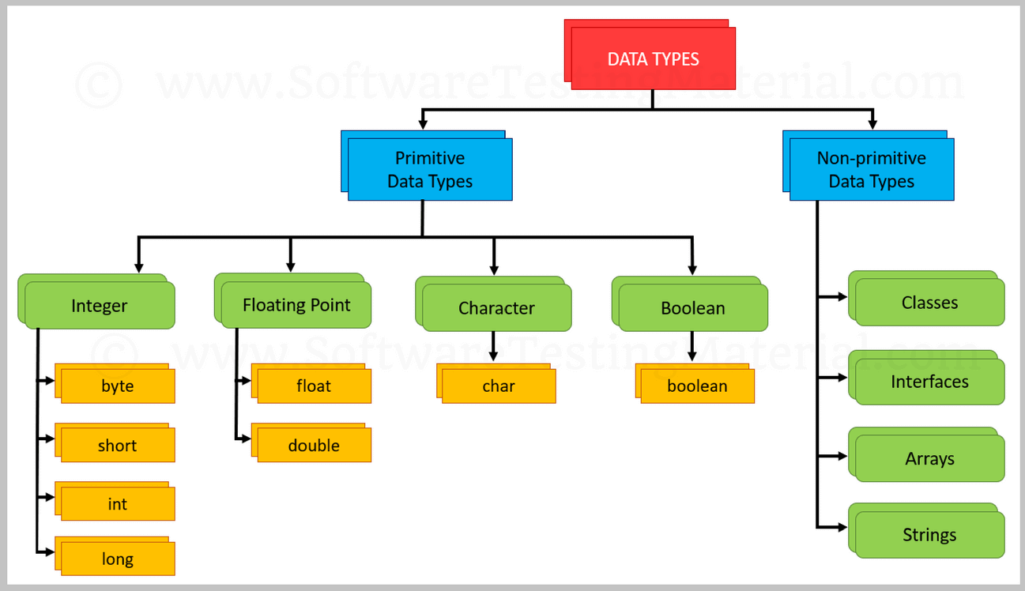

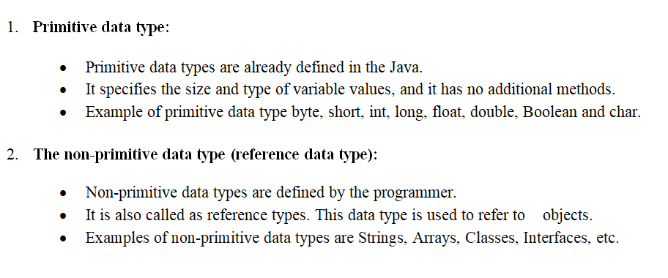

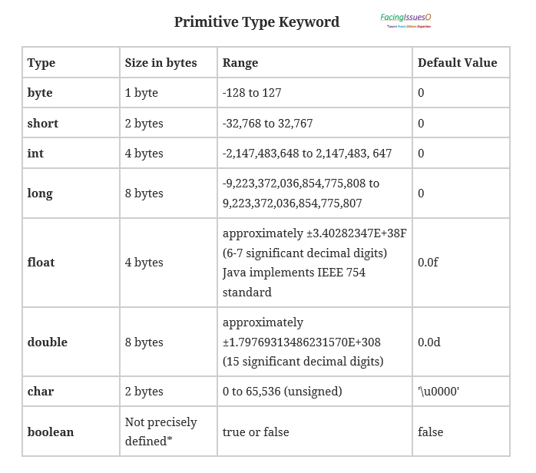

int a;

char c =’a’;

int a=8;

print “a”

-2^(n-1) to 2^(n-1)-1

-2^(8-1) to 2^(8-1)-1=🡺

Byte/Short/int/Long🡪 Integer

Char🡪Keyboard🡪 Character

FLOAT & DOUBLE

Float🡪 Single Precision 🡪 6 or 7 digits 🡪 3.14[f/F]

Double Precision 🡪 14 or 15 digits

**********************************************************************************

STRING 🡪Group of characters

ARRAY 🡪Collection of elements

CLASS 🡪Class consists of variables and methods

*************************************************************************************

WRAPER CLASS: Convert data type into class object used in collection

[int 🡪 integer & char 🡪 character]

*********************************************************************************

OOPS INTRODUCTION:

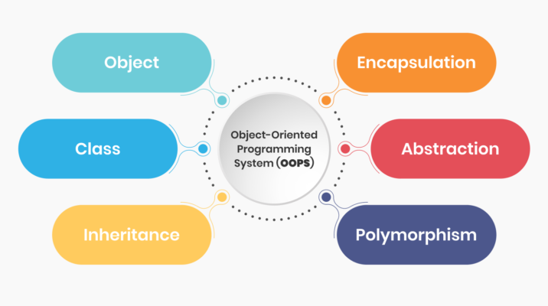

**OOPS: - Object Oriented Programming Structure**

**The structure of implementation in which our programs are organized in the form of Class, Methods and Objects**

**Class:**

**🡪Collection of methods and objects**

**Methods:**

**🡪Set of actions to be performed**

**Object:**

**🡪Instance of class**

**new keyword- it allocates new memory**

**it helps to call the method**

**Syntax:**

**ClassName Obj.name = new ClassName();**

**Oops Concepts:**

* **Encapsulation**
* **Inheritance**
* **Polymorphism**
* **Abstraction**